METACOGNITIVE REFLECTIONS

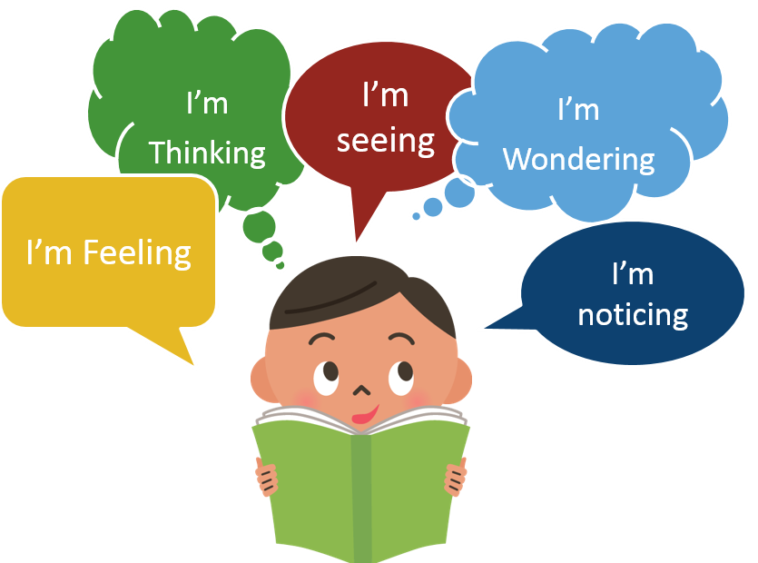

METACOGNITIVE REFLECTION: 3-2-1
3
2
1

Metacognitive Reflection: Using the Multiple Intelligences Grid

+ | - | i
PLUS | MINUS | INTRIGUING

METACOGNITIVE REFLECTION

Question 1: Which theory do you feel has had or could have the greatest positive impact on improving student achievement? Why?
______________________________________________________________________________________________________________________________________________________________________________________________________________________________________________________________________________________________________________________________________________________________________________________________________________________________________________________
Question 2: Which theory do you feel has had or could have the greatest positive impact on improving student behavior? Why?
_______________________________________________________________________________________________________________________________________________________________________________________________________________________________________________________________________________________________________________________________________________________________________________________________________________________________________________________________________________________________________________________________

METACOGNITIVE REFLECTION: INTERPERSONAL SKILLS PROBLEM-SOLVING APPLICATION
Directions: Review the strategies in this chapter and brainstorm possible solutions to a real problem you have with a student.
1. Write a brief description of a student you have taught or are currently teaching who has poor interpersonal skills.
Student’s First Name: _________________________ Age: ______ Grade: ______

Description of Problem

2. Based upon the strategies reviewed in this chapter and your own ideas, brainstorm possible solutions to the problem.
Solution:

METACOGNITIVE REFLECTION

I’m feeling

I’m thinking

I’m seeing

I’m wondering

I’m noticing

METACOGNITIVE REFLECTION: CLOSURE
- Write down five new strategies you plan to implement in your classroom.
- Pair with a partner.
- One person talks for one minute; the other person talks for one minute.
- Alternate talking for thirty seconds.
- Alternate talking for fifteen seconds.

Strategy #1

___________________________________________________________________________

Strategy #2

___________________________________________________________________________

Strategy #3

___________________________________________________________________________

Strategy #4

___________________________________________________________________________

Strategy #5

___________________________________________________________________________

