Assignment #1
Chunking a Lesson

Direct Instruction:

Group Interaction:

Group Sharing:

Group Application:

Group Sharing:

Direct Instruction:

Group Interaction:

Group Sharing:

Individual Application:

Assignment #2
Multiple Intelligences Grid

Subject Area: ____________________________________________________
Standards: _______________________________________________________
_________________________________________________________________
_________________________________________________________________
List at least three learning experiences/assessments under each intelligence.
VERBAL/  LINGUISTIC | LOGICAL/  MATHEMATICAL | VISUAL/  SPATIAL | BODILY/  KINESTHETIC
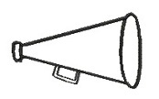

MUSICAL/  RHYTHMIC | INTERPERSONAL | INTRAPERSONAL | NATURALIST
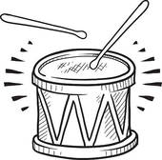 |  | 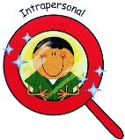 | 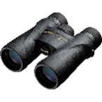

Whole-class
learning
experiences

Whole-class assessments for learning experiences

Culminating event for unit

Assignment #3
Classroom Rules and Consequences

Directions: Develop five rules and logical consequences for violating the rules that are appropriate for your students.

Teacher: ________________ Class/Grade: ________________ Date: ______

Rule #1: _________________________________________________________

Consequences: 1. _________________________________________________

2. _________________________________________________

3. _________________________________________________

4. _________________________________________________

5. _________________________________________________

Rule #2: _________________________________________________________

Consequences: 1. _________________________________________________

2. _________________________________________________

3. _________________________________________________

4. _________________________________________________

5. _________________________________________________

Rule #3: _________________________________________________________

Consequences: 1. _________________________________________________

2. _________________________________________________

3. _________________________________________________

4. _________________________________________________

5. _________________________________________________

Rule #4: _________________________________________________________

Consequences: 1. _________________________________________________

2. _________________________________________________

3. _________________________________________________

4. _________________________________________________

5. _________________________________________________

Rule #5: _________________________________________________________

Consequences: 1. _________________________________________________

2. _________________________________________________

3. _________________________________________________

4. _________________________________________________

5. _________________________________________________

Assignment #4
Social Skills Lesson
Directions: Select one social skill and plan how to teach it to your students.

Targeted Social Skill: ______________________________________________

Stage 1 – Create the Hook:

Stage 2 – Teach the Skill:

Stage 3: Practice the Skill:

Stage 4: Observe the Skill:

Stage 5: Reflect on the Skill:

Stage 6: Recognize and Celebrate Success:

Stage 7: Transfer Skill Outside the Class:

Assignment #5
Cooperative Group Activity
Directions: Create a cooperative group activity. Include the formation of groups, role assignments and what their role is, the task, time limit, social skill, and an energizer.

Assignment #6

Students Who Don’t Accept Responsibility

Problem-Solving Model

Student: ______________________________________________ Date: _____________
Teacher: ______________________________________________

Student’s Description of the Problem:

Teacher’s Description of the Problem:

Identify the Real Problem
Student:

Teacher:

Possible Solutions:
1.

2.

3.

Signed: Teacher: ______________________________ Student: _________________________ Date: _______________
Point/Counterpoint Strategy

The teacher and student meet to discuss the issue using the point/counterpoint strategy. The teacher first fills out his or her points, and the student responds to those points in the counterpoint section.

Student: __________________________ Teacher: _______________________
Date: _________________

TEACHER’S POINTS | STUDENT’S COUNTERPOINTS

COMPROMISE SOLUTION
TEACHER:

STUDENT:

Signed: Teacher: _____________________ Student: ________________________ Date: ________________

Decision-Making Model

Start

WHAT IS THE DECISION TO BE MADE?

ALTERNATIVES

CONSEQUENCES
+
+
+

-
-
-

FINAL DECISION

Student: ___________________ Teacher: ___________________ Date: _______________

Mailgram
MAILGRAM
Date:
Message to:
From:

MAILGRAM
Date:
Message to:
From:

Assignment #7

Students Who LACK INTERPERSONAL SKILLS

Social Contract

Student: __________________ Teacher: ________________ Date: ____________

Teacher: Describe the problem.
______________________________________________________________________
______________________________________________________________________

Student: What is your reaction to the problem your teacher has described?
______________________________________________________________________
______________________________________________________________________

Teacher and Student: Decide on a social contract to help solve the problem.
Steps taken by the teacher:
1. ________________________________________________________________
2. ________________________________________________________________
3. ________________________________________________________________

Steps taken by the student:
1. ________________________________________________________________
2. ________________________________________________________________

Positive consequences of fulfilling the social contract:
1. ________________________________________________________________
2. ________________________________________________________________
3. ________________________________________________________________

Negative consequences of not fulfilling the social contract:
1. ________________________________________________________________
2. ________________________________________________________________
3. ________________________________________________________________
Timeline for contract: _________________

Signed: __________________________ Signed: ___________________________

Decision-Making Model Template

Student: ______________________________ Date: __________

Teacher: ____________________________

Teacher’s View of Problem

Student’s View of Problem

Solutions to Problem
Solution #1 |  | Pro  Con
Solution #2 |  | Pro  Con
Solution #3 |  | Pro  Con
Solution #4 |  | Pro  Con
Final Decision |  | Reasons
Cause and Effect Model

Student: __________________ Date: __________ Teacher: __________________

Specific Behavior Effect It Could Have on Others
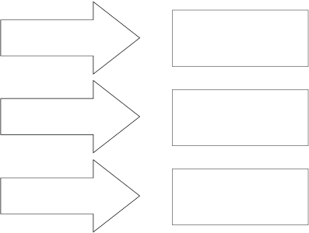
Reflection on Behaviors ___________________________________________________
_______________________________________________________________________
_______________________________________________________________________
_______________________________________________________________________
Targeted Behavior to Change _______________________________________________
_______________________________________________________________________
_______________________________________________________________________

Signed: _______________________________ Date: _________________

Social Contract/Action Plan

Student: _________________ Teacher: __________________ Date: ________________

Teacher’s Perception of Problem:__________________________________________________
_____________________________________________________________________________
_____________________________________________________________________________

Student’s Perception of Problem:___________________________________________________
_____________________________________________________________________________
_____________________________________________________________________________

Possible Strategies:
1. ________________________________________________________________
2. ________________________________________________________________
3. ________________________________________________________________
4. ________________________________________________________________
5. ________________________________________________________________

Create an Action Plan: The student will do the following:
Step 1 – Week One Step 2 – Week One

Step 3 – Week Two Step 4 – Week Two

What the teacher will do to assist the student in following the action plan:

Signatures: ______________ ________________ __________________
Student Teacher Parent (optional)
Date to Review Progress: ___________________________
The Newspaper Model

Name: ________________________________ Date: ________________
Problem: _______________________________________________________________

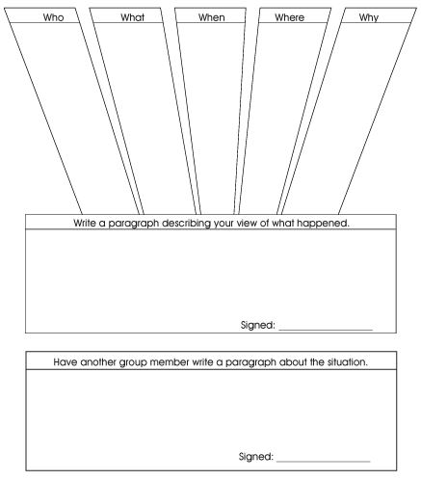

Phases of a Power Struggle
EXPLOSIONS
CAUSES COOL DOWN
1. _________________ 1. __________________
_________________ __________________
2. _________________ 2. __________________
_________________ __________________
3. _________________ 3. __________________
_________________ __________________

What the teacher could have done to prevent the problem:

What the student could have done to prevent the problem:

Resolution to problem:

Teacher: __________________ Student: ______________________ Date: _______________

Divided Journal

Student: ______________ Date: _______  Description of What Happened | Upon Reflection Date: ___________  What I Would Do Differently
Teacher: ______________ Date: _______  Description of What Happened | Upon Reflection Date: ___________  What I Would Do Differently

Action Plan

Students:

Problem:
QUICK-RECOVERY ACTIONS

NEXT-STEP ACTIONS

LONG-TERM SOLUTIONS

Assignment #8
MOTIVATIONAL ACTIVITY

Directions: In one paragraph explain an activity you found to be successful in motivating students.

______________________________________________________________________

______________________________________________________________________

______________________________________________________________________

______________________________________________________________________

______________________________________________________________________

______________________________________________________________________

______________________________________________________________________

______________________________________________________________________

______________________________________________________________________

