Name
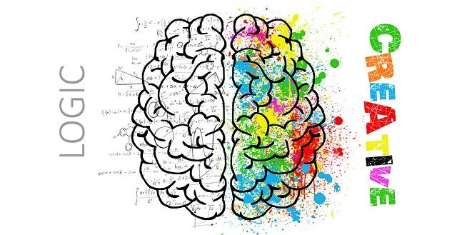
Critical and Creative Thinkers for a Global Age
UNY 832

“Education is not the learning of facts, but the training of the mind to think”
– Albert Einstein

Critical and Creative Thinkers for a Global Age
UNY 832
Adelphi University
Your Name
Your Email@gmail.com
Jacqueline Nett
jackienett75@gmail.com

Table of Contents

Assessment 1: Thinkscape Reflection……………………………………………………………………………… page #’s
Assessment 2: Article Reviews…………………………………………………………………………………..Page #’s
Article 1………………………………………………….…………………………………Page #
Article 2…………………………………………………………………………………….Page #

Article 3…………………………………………………………………………………Page #

Article 4…………………………………………………………………………………...Page#

Assessment 3: Thinking and Communication Skills Lesson…………………………………….

Assessment 4: Inferential Reasoning and Logical Fallacies
Lesson…………………………..

Assessment 5: Thinking from Multiple Perspectives Lesson……………………………..….…

Assessment 6: Creative Problem Solving Lesson……………………………………………….…..

Assessment 7: Action Plan………………………………………………………………………………………..Page #
Self-Evaluation…………………………………………………………………………...Page #
WorksCited……………………………………………………………………………… Page#

Assessment 1: Thinkscape Reflection

1. Why is it important for students to learn how to think?

2. Why is it important for students to understand the standards of and barriers to critical thinking?

3. Why is it important for students in a global age to be skilled in creative thinking?

4. Why is it important for students to communicate precisely and effectively?

5. Why is it important for students to be conscious of the inferences and assumptions they make?

6. Why is it important for students to recognize logical fallacies?

7. Why is it important for students to think from multiple perspectives?

8. Why is it important for students in a global age to be skilled in creative problem solving?

9. Why is it important for students to be skilled in media literacy?

10. Why is it important to establish a culture of thinking?

Assessment 2: Article Reviews

Article 1:

Article:
Author-
Publication-
Date-

Key Ideas:

Summary:

Professional Reaction:
Classroom Application:

Article 2:

Article:
Author-
Publication-
Date-

Key Ideas:

Summary:

Professional Reaction:
Classroom Application:

Article 3:

Article:
Author-
Publication-
Date-

Key Ideas:

Summary:

Professional Reaction:
Classroom Application:

Article 4:

Article:
Author-
Publication-
Date-

Key Ideas:

Summary:

Professional Reaction:
Classroom Application:

Lesson Plans

Assessment 3: Thinking and Communication Skills

Lesson Plan:

Assessment 4: Inferential Reasoning and Logical Fallacies

Lesson Plan: Making Inferences

Assessment 5: Thinking from Multiple Perspectives

Lesson:

Assessment 6: Creative Problem Solving

Lesson:

Assessment 7: Action Plan (One page)

Self Evaluation:

Works Cited:

